**Lab3.1: Basic VLAN Configuration**

**Topology**

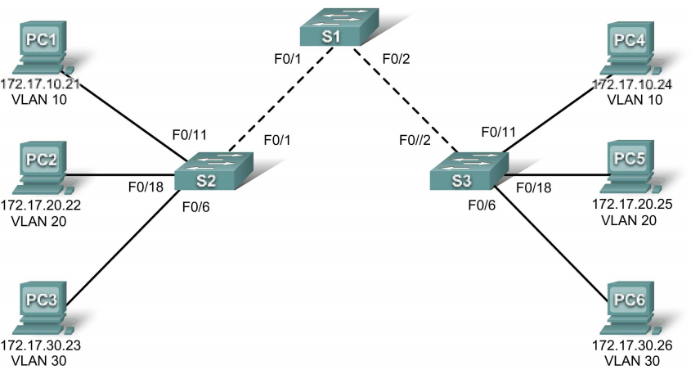

**Addressing table**

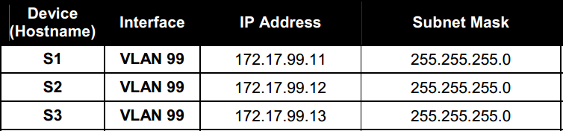

**Initial port assignment**

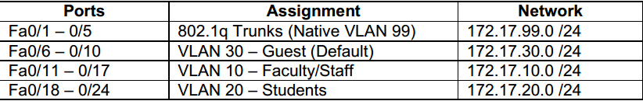

**Task 1: Prepare the Network**  
**Step 1: Cable a network that is similar to the one in the topology diagram.**  
**Step 2: Clear any existing configurations on the switches, and initialize all ports in the shutdown** **state.**  
It is a good practice to disable any unused ports on the switches by putting them in shutdown. Disable all ports on the switches:  
Switch#**config term**  
Switch(config)#**interface range fa0/1-24**  
Switch(config-if-range)#**shutdown**  
Switch(config-if-range)#**interface range gi0/1-2**  
Switch(config-if-range)#**shutdown**

**Task 2: Perform Basic Switch Configurations**  
**Step 1: Configure the switches according to the following guidelines.**  
• Configure the switch hostname.  
• Configure an EXEC mode password of **class**.  
• Configure a password of **cisco** for console connections.  
• Configure a password of **cisco** for vty connections.

**Step 2: Re-enable the user ports on S2 and S3.**  
S2(config)#**interface range fa0/6, fa0/11, fa0/18**  
S2(config-if-range)#**switchport mode access**

S2(config-if-range)#**no shutdown**  
S3(config)#**interface range fa0/6, fa0/11, fa0/18**  
S3(config-if-range)#**switchport mode access**  
S3(config-if-range)#**no shutdown**

**Task 3: Configure and Activate Ethernet Interfaces**  
**Step 1: Configure the PCs.**

**Task 4: Configure VLANs on the Switch**  
**Step 1: Create VLANs on switch S1.**  
Use the **vlan** *vlan****-****id* command in global configuration mode to add a VLAN to switch S1. There are four VLANS configured for this lab: VLAN 10 (faculty/staff); VLAN 20(students); VLAN 30 (guest); and VLAN99 (management). After you create the VLAN, you will be in vlan configuration mode, where you can assign a name to the VLAN with the **name** *vlan name* command.  
S1(config)#**vlan 10**  
S1(config-vlan)#**name faculty/staff**  
S1(config-vlan)#**vlan 20**  
S1(config-vlan)#**name students**  
S1(config-vlan)#**vlan 30**  
S1(config-vlan)#**name guest**  
S1(config-vlan)#**vlan 99**

S1(config-vlan)#**name management**  
S1(config-vlan)#**end**  
S1#  
**Step 2: Verify that the VLANs have been created on S1.**  
Use the **show vlan brief** command to verify that the VLANs have been created.  
S1#**show vlan brief**

**Step 3: Configure and name VLANs on switches S2 and S3.**  
Create and name VLANs 10, 20, 30, and 99 on S2 and S3 using the commands from Step 1. Verify the correct configuration with the **show vlan brief** command.  
What ports are currently assigned to the four VLANs you have created?

**Step 4: Assign switch ports to VLANs on S2 and S3.**  
Refer to the port assignment table on page 1. Ports are assigned to VLANs in interface configuration mode, using the **switchport access vlan** *vlan-id* command. You can assign each port individually or you can use the **interface range** command to simplify this task, as shown here. The commands are shown for S3 only, but you should configure both S2 and S3 similarly. Save your configuration when done.  
S3(config)#**interface range fa0/6-10**  
S3(config-if-range)#**switchport access vlan 30**  
S3(config-if-range)#**interface range fa0/11-17**  
S3(config-if-range)#**switchport access vlan 10**  
S3(config-if-range)#**interface range fa0/18-24**  
S3(config-if-range)#**switchport access vlan 20**  
S3(config-if-range)#**end**  
S3#**copy running-config startup-config**  
Destination filename [startup-config]? [enter]  
Building configuration...  
[OK]  
**Step 5: Assign the management VLAN.**  
A management VLAN is any VLAN that you configure to access the management capabilities of a switch. VLAN 1 serves as the management VLAN if you did not specifically define another VLAN. You assign the management VLAN an IP address and subnet mask. The out-of-the-box configuration of a Cisco switch has VLAN 1 as the default VLAN, VLAN 1 is a bad choice as the management VLAN. You do not want an arbitrary user who is connecting to a switch to default to the management VLAN. Recall that you configured the management VLAN as VLAN 99 earlier in this lab.  
From interface configuration mode, use the **ip address** command to assign the management IP address to the switches.  
S1(config)#**interface vlan 99**  
S1(config-if)#**ip address 172.17.99.11 255.255.255.0**  
S1(config-if)#**no shutdown**  
S2(config)#**interface vlan 99**  
S2(config-if)#**ip address 172.17.99.12 255.255.255.0**  
S2(config-if)#**no shutdown**  
S3(config)#**interface vlan 99**  
S3(config-if)#**ip address 172.17.99.13 255.255.255.0**

**Step 6**: **Configure trunking and the native VLAN for the trunking ports on all switches.**

Use the **interface range** command in global configuration mode to simplify configuring trunking.

S1(config)#**interface range fa0/1-5**  
S1(config-if-range)#**switchport mode trunk**  
S1(config-if-range)#**switchport trunk native vlan 99**  
S1(config-if-range)#**no shutdown**  
S1(config-if-range)#**end**  
S2(config)# **interface range fa0/1-5**  
S2(config-if-range)#**switchport mode trunk**  
S2(config-if-range)#**switchport trunk native vlan 99**  
S2(config-if-range)#**no shutdown**  
S2(config-if-range)#**end**  
S3(config)# **interface range fa0/1-5**  
S3(config-if-range)#**switchport mode trunk**   
S3(config-if-range)#**switchport trunk native vlan 99**  
S3(config-if-range)#**no shutdown**  
S3(config-if-range)#**end**

**Step 7: Verify that the switches can communicate.**  
From S1, ping the management address on both S2 and S3.  
S1#**ping 172.17.99.12**  
Is the ping attempt successful? _________  
S1#**ping 172.17.99.13**  
Is the ping attempt successful? _________  
**Step 8: Ping several hosts from PC2.**  
Ping from host PC2 to host PC1 (172.17.10.21). Is the ping attempt successful? _________  
Ping from host PC2 to the switch VLAN 99 IP address 172.17.99.12. Is the ping attempt successful?  
_________  
Ping from host PC2 to host PC5. Is the ping attempt successful? _________